

Query Use Case & Implementation Guide
Template
Version 1 (DRAFT)
September 29, 2014
Note: Text in blue indicates a placeholder that will need to be updated with actual content.

Table of Contents
1.0 Introduction 4
1.1. Background 4
1.2. Purpose and Vision 4
1.3. Stakeholders and Target Audience 4
1.4. Scope of Work 5
1.5. Deliverables 6
1.6. Constraints 6
1.7. Timeframe for Completing Work 6
2.0 Requirements Executive Summary 7
2.1. Summary of Use Cases 7
2.1.1. Simple Query 7
2.1.2. Record Locator Service Facilitated Query 7
2.2. Clinical Requirements 8
2.3. Business Requirements 8
3.0 Simple Query Use Cases 9
3.1. Background 9
3.2. Pre-conditions and Assumptions 9
3.3. Use Case #1 9
3.3.1. Actors 10
Use Case Steps 10
3.3.2. 10
3.3.3. Post-conditions 10
3.3.4. Alternate Flows 11
3.3.5. Error Flows 11
3.3.6. Notes 11
3.3.7. Questions 11
4.0 Record Locator Service (RLS) Use Cases 13
4.1. Background 13
4.2. With an RLS Example 13
4.3. Pre-conditions and Assumptions 13
4.4. [Use Case Name] 13
4.4.1. Actors 13
4.4.2. Use Case Steps 14
4.4.3. Post-conditions 14
4.4.4. Errors 14
5.0 Record Locator Service Conceptual Architecture 15
5.1. Location EHR with XCA Support 16
5.2. Location EHR with Direct Messaging Support, Using the RLS as a Gateway 16
5.3. RLS Serving As a Location EHR 16
6.0 Technical Requirements 16
7.0 Detailed Architecture 16
8.0 Implementation Guides 16
8.1. Simple Query 16
8.2. Record Locator Service 17

Introduction

Background
While substantial progress has been made to advance interoperable exchange of health information, existing networks are generally defined by particular technology platforms, use cases, or geographies. This has resulted in multiple networks that operate independently of one another. The HIE space is rapidly evolving, with new types of networks emerging (e.g. vendor-based networks, release of information companies, private HIEs formed by payers). There is a need for a unifying set of implementation-level requirements that apply universally across all of these networks to enable health information to flow seamlessly and securely. Industry stakeholders have expressed a strong preference to have these requirements developed through a public-private collaborative process, with support and participation by the federal government. To that end, Carequality’s mission is analogous to the collaboration of the banking industry to ATM networks.
Carequality was established with a three-tier governance structure, which includes a Steering Committee, two workgroups, and Advisory Council. The Query Workgroup was established to solve specific interoperability challenges related to query of health information. The Workgroup is responsible for developing use case(s) and implementation guide for specific interoperability capabilities, the first of which is focusing on query-based exchange. The Query Workgroup will work under the guidance of the Steering Committee and Advisory Council, and ensure that its work aligns with the universal set of trust principles developed by the Trust Framework Workgroup.

Purpose and Vision
The purpose of the Query Workgroup is to develop use case(s) and implementation guide that outlines business, technical, testing and policy requirements to enable simple query of information between and among networks. Under the advice and guidance of the Steering Committee, and with input from the Advisory Council, the Workgroup will come to agreement regarding how to bridge query-based exchanges based upon differing technology platforms and architectures. The Query Workgroup must focus on the broad needs for industry and remain grounded in existing capabilities implemented in production.

Stakeholders and Target Audience
- Senior Executives
  - Pertinent Sections: Executive Summary
- Senior Technical Executives (e.g., CIOs, CMIOs, CTOs, Chief Privacy and Security Officers)
  - Pertinent Sections: All sections, except for the Implementation Guide
- Implementation Engineers
  - Pertinent Sections: All sections, with a specific focus on the Implementation Guide

Scope of Work
The Query Work Group should focus on:
- Simple query of health information from known target(s)
- Record-locator facilitated query of health information
- The ability for networks with different architectures to bridge and support query-based exchange

The Workgroup must leverage existing capabilities deployed in production in the US, while taking into account the Trust Framework as a guide. In addition, the Workgroup shall determine how best to facilitate exchange between emerging and differing technology platforms and architectures, as well as differing transport protocols (e.g. SOAP, RESTful) and data types (e.g. document-based exchange, message-based exchange, API-based). To guide its work, it is expected that the Workgroup will consider lessons learned from other use case development efforts and actively seek input from subject matter experts, when appropriate.

A query use case includes a set of functions and related requirements and is intended to establish how different architectural approaches can be bridged to enable seamless exchange. Since this work is intended to extend existing connectivity and interoperability, the Workgroup shall leverage existing standards and implementation specifications. In the event additional specifications are needed to bridge between different architectural approaches, the Work Group, in consultation with the Steering Committee and Advisory Council shall coordinate with related standards development organizations (SDOs) and other initiatives (e.g. ONC Standards and Interoperability Framework, EHR-HIE Interoperability Work Group, etc.). The objective is to work with SDOs and existing initiatives as much as possible to avoid redundant work.

The Query Workgroup is expected to focus on a two-phased approach:
Phase 1
Develop two query requirements for the following:
- Enabling the exchange of health information between and among networks for simple query
- Record locator service facilitated query between and among networks
It is recommended that the Workgroup focus on developing the simple query case prior to the record locator service facilitated query use case.
This phase should also include pilot demonstrations to prove that the use case and implementation guide are implementable. It is expected that the pilot demonstrations would be followed with pilot implementations as the final use case and implementation guide are deployed.

Phase 2
The second phase will focus on developing a set of requirements as a supplement to the Query Use Case and Implementation Guide that specifies how to bridge query-based exchange between networks that utilize different architectural approaches (“Query Bridge Architecture”).
This phase should also include pilot demonstrations to prove that the use case and implementation guide are implementable. It is expected that the pilot demonstrations would be followed with pilot implementations as the final use case and implementation guide are deployed.

Deliverables
The use case deliverables should:
- Be simple and straightforward.
- Document a core set of business requirements that reflect the needs of clinician end users.
- Enable query-based exchange based upon current architectural approaches, standards and implementation specifications.
- Accommodate different architectural approaches.
- Leverage existing capabilities to the greatest extent possible (e.g., existing testing programs and specifications).
- Remain consistent with the universal set of policies established in the Trust Framework.
- Define a set of use case specific policies using the Trust Framework as a guide.

Deliverables will consist of the following:
- Periodic presentations, as deemed appropriate or requested, to the Steering Committee and Advisory Council to describe status of Work Group efforts and capture lessons learned and key findings.
- Steering Committee approved query use case and implementation guide that defines the business requirements, technical functionality, testing approach and use case specific policies.

Constraints
[Insert description]

Timeframe for Completing Work
Activity | Targeted Completion Date
Phase 1: Develop Query Use Case & Implementation Guide
Draft Query Use Case & Implementation Guide | Late November 2014
Advisory Council and Steering Committee review draft Query Use Case & Implementation Guide | December 2014
Finalize Draft Query Use Case & Implementation Guide | January 2015
Advisory Council reviews final draft | February 2015
Steering Committee approves final Query Use Case & Implementation Guide | March 2015
Pilot demonstrations | TBD
Phase 2: Bridge Query Architectures
Propose detailed scope of work for phase 2 work to Steering Committee | Fall 2014
Draft Bridge Use Case for different query architectures | November 2014
Advisory Council and Steering Committee review Bridge Deliverable | December 2014
Finalize Draft Bridge Deliverable | January 2015
Advisory Council reviews Final Draft Bridge Deliverable | February 2015
Steering Committee approves Final Bridge Deliverable | March 2015
Pilot demonstrations | TBD

Requirements Executive Summary
The Requirements document will focus on Phase 1 of the Scope of Work in developing query requirements for the following:
- Enabling the exchange of health information between and among networks for simple query;
- Record locator service facilitated query between and among networks

Summary of Use Cases

Simple Query
The Simple Query uses cases define common implementation patterns for requesting patient health information. The scenario described in the next section is one example of using simple query for the purpose of obtaining a patient's clinical information.

Scenario for Simple Query
A patient needs emergency care and presents at the ED of a hospital. The hospital is able to obtain identifying information about the patient by a family member who accompanies that individual. The hospital submits an inquiry to other eHealth Exchange participants within the treatment area where most of the hospital’s patients receive care. This includes an academic medical center, VA medical center, community hospital (connected through a regional HIO) and a number of primary care and specialists. Within seconds, the hospital receives a list of all of the places where the individual received care. The ED then sends a query to each of (???) those treatment providers requesting a copy of the patient’s records. Upon receipt of the records, the ED has a comprehensive view of the patient’s history, drug and other allergies, etc...

Record Locator Service Facilitated Query
The Record Locator Service Facilitated Query uses cases define common implementation patterns for finding where patients have been previously seen for care outside of the network in which the querying system is connected, and, when needed, collecting patient consent to share information. The scenario described in the next section is one example of locating patient records for the purpose of obtaining the patient's clinical information.

Scenario for the RLS
A patient is taken to the ED of a medical center (the Requesting EHR). During the admission process, the patient informs a front desk staff member about being seen at several clinics and hospitals in his hometown, but can’t remember all of them.
Using the patient’s demographics, the staff member queries a Record Locator Service (RLS) and promptly gets a successful match. The Record Locator Service indicates that, due to its business agreement, the patient’s consent is required before it can return a list of organizations that have records containing the patient’s clinical information.
After the patient’s consent is collected, the staff member receives the list of organizations known to the Record Locator Service and sends (or the system sends???) queries to the organizations whose records are relevant to this ED visit.

Clinical Requirements
[Insert description]

Business Requirements
[Insert description]

Simple Query Use Cases

Background
These use cases describe the actors, transactions, and requirements to enable the exchange of health information between and among networks for simple query.

Pre-conditions and Assumptions
Pre-conditions
- Pre-condition for main flow: initiating gateway knows the patient demographics and/or id and the HCIDs and endpoints of the node(s) they have been seen
  - Other flows have different assumptions
- [Insert pre-condition 2]
- [Insert pre-condition 3]
Assumptions
1. [Insert assumption]
2. […]

Use Case #1
[Insert summary of use case]
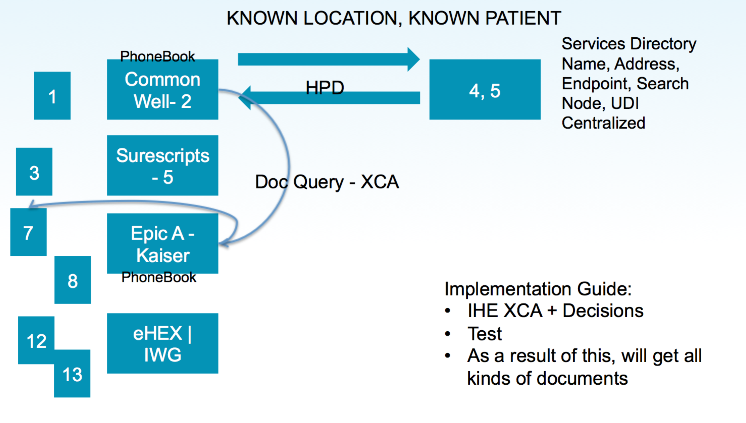

Actors
- Initiating gateway (multiplicity of 1)
- Responding gateway (multiplicity of 1..*)
- Participant Gateway Directory, i.e. phonebook (e.g. UDDI or HPD) (multiplicity of 0..*)

Use Case Steps

- This use case begins when the Initiating Gateway sends an IHE Cross Gateway Patient Discovery [ITI-55] request to a Responding Gateway to attempt to match a patient by demographics. The request includes patient demographics (e.g. name, gender, date of birth) as known by the Initiating Gateway. See IHE ITI TF Vol 1: 27.1.2.1 Cross Gateway Patient Discovery [ITI-55] and IHE ITI TF Vol 2b: 3.55.
- The Responding Gateway compares the demographics to its known patients, applying its own algorithm to determine matches, and returns an IHE ITI-55 response to the Responding Gateway. The response contains a single patient match, including demographics and ID as known by the Responding Gateway.
- The Initiating Gateway sends an IHE Cross Gateway Query [ITI-38] “Find Documents” request to the Responding Gateway to query for documents for this patient. “Find Documents” refers to the fact that the ITI-38 request has multiple flavors, known as stored queries, such as Find Folders and Get Associations. Find Documents is the most basic query. The request includes the patient ID at the Responding Gateway and the status of urn:oasis:names:tc:ebxml-regrep:StatusType:Approved. Approved in this context means the document is available for patient care. See IHE ITI TF Vol 1: 18 Cross-Community Access (XCA) Integration Profile, IHE ITI TF Vol 2b: 3.38, and IHE ITI TF Vol 2a: 3.18.
- The Responding Gateway filters its known documents by the query parameters passed in and returns an ITI-38 response containing a number of document entries. A document entry is a set of attributes (i.e. metadata) about a single document, not the document itself. In the document entry is a tuple of IDs (Home Community ID, Repository ID, and Document unique ID) that enable an Initiating Gateway to later retrieve the actual document. See IHE ITI TF Vol 3: 4.2.1.1 DocumentEntry.
- The Initiating Gateway sends an IHE Cross Gateway Retrieve [ITI-39] request to the Responding Gateway to retrieve documents. The request includes the document/repository/community IDs at the Responding Gateway. See IHE ITI TF Vol 1: 18 Cross-Community Access (XCA) Integration Profile, IHE ITI TF Vol 2b: 3.39, and IHE ITI TF Vol 2b: 3.43.
- The Responding Gateway retrieves the requested documents from its repositories and returns an ITI-39 response containing the documents and their related IDs.

Post-conditions
- The Initiating Gateway has obtained the patient ID and demographics as known by the Responding Gateway.
- The Initiating Gateway has obtained the desired document entries as known by the Responding Gateway.
- The Initiating Gateway has obtained the desired documents from the Responding Gateway.

Alternate Flows
- Use of Participant Gateway Directory
- Multiple responding gateways
- Patient feed mode
  - The request includes a patient ID as known by the Initiating Gateway. The Responding Gateway can …
- Patient consent exception
  - Notes: Will allow for exchange of patient consent not available exceptions from disclosing party to initiating party
  - Initiating party provides patient consent to disclosing party
- Ambiguous vs. non-ambiguous XCPD responses
  - Note: Need to decide which we will support, then which will be nominal and which is alternate/exceptional
- Query parameter support
  - Note: Differences in behavior using same parameters
- Advanced XCA queries: folders, associations, submission sets, etc.
  - Also status based (e.g. query for deprecated)
- Variations of returned document
  - Notes: nonconformance, different interpretations, etc.
- Responding gateway hides/exposes network
  - Notes: affects use of HCIDs
- Heterogeneous results from network
  - Example: source A says here you go, source B says no go
- Variations in use of OIDs: AAIDs, RIDs, HCIDs
- Interop issues based on different interpretation of doc content rules
- Longitudinal documents
  - Effect on date queries
- Advanced query processing
  - Example: include allergies irrespective of date ranges
  - In general, solve the problem of what information is carried over for date-restricted query
- On-demand documents
- Use of provider directory (e.g. to identify specialists within an area for the purpose of determining whom to query for patient records)
2. […]

Error Flows
1. [Insert error]
2. […]

Notes
- There is a nuance with Home Community IDs.

Questions
- Does the flow “known patient, known location” require a Participant Gateway Directory?

Record Locator Service (RLS) Use Cases

Background
These use cases describe the actors, transaction, and requirements involved in a record locator service facilitated query between and among networks.
Before an EHR system can query for a patient's record, it needs to know where else the patient has been seen. The following examples highlight the role of an RLS under this Carequality Use Case.

With an RLS Example
An ED EHR queries the RLS using the patient’s demographics, learns where the patient may have a chart, and then queries those places directly for the patient’s chart.
To learn where a patient might have a chart, the RLS may have direct access to other systems, it may have an ADT feed from many systems, or it may use claims or e-Prescribing data.
An RLS service could be part of a variety of other care scenarios, such as collecting information for care coordination, requesting charts in advance of upcoming visits, or finding appropriate recipients to receive a discharge summary – any care scenario where previous care providers need to be identified.

Pre-conditions and Assumptions
Pre-conditions
- [Insert pre-condition 1]
- [Insert pre-condition 2]
- [Insert pre-condition 3]
Assumptions
1. [Insert assumption]
2. […]

[Use Case Name]
[Insert summary of use case]

Actors
Actor | Role
Requesting EHR | Requesting System
Record Locator Service (RLS) | Responding System
RLS Serving as Location EHR | Responding System
[Insert additional actors]

Use Case Steps
- [Insert step 1]
- [Insert step 2]
- [Insert step 3]

Post-conditions
- [Insert post-condition 1]
- [Insert post-condition 2]
- [Insert post-condition 3]

Errors
- [Insert error]
- […]

Record Locator Service Conceptual Architecture
The approaches in this section describe how to add an RLS to the processes that EHRs use today to exchange information.
The RLS is different from a typical centralized Master Patient Index (MPI) in a Health Information Exchange (HIE) community. While a regional or other HIE might choose to provide RLS services in addition to the other services it provides, the RLS is not dependent on an HIE structure and may operate without geographical boundaries. Participants in the network may exchange information directly with each other when appropriate, without consulting an RLS. An EHR might subscribe to services from one RLS or from multiple RLSs.
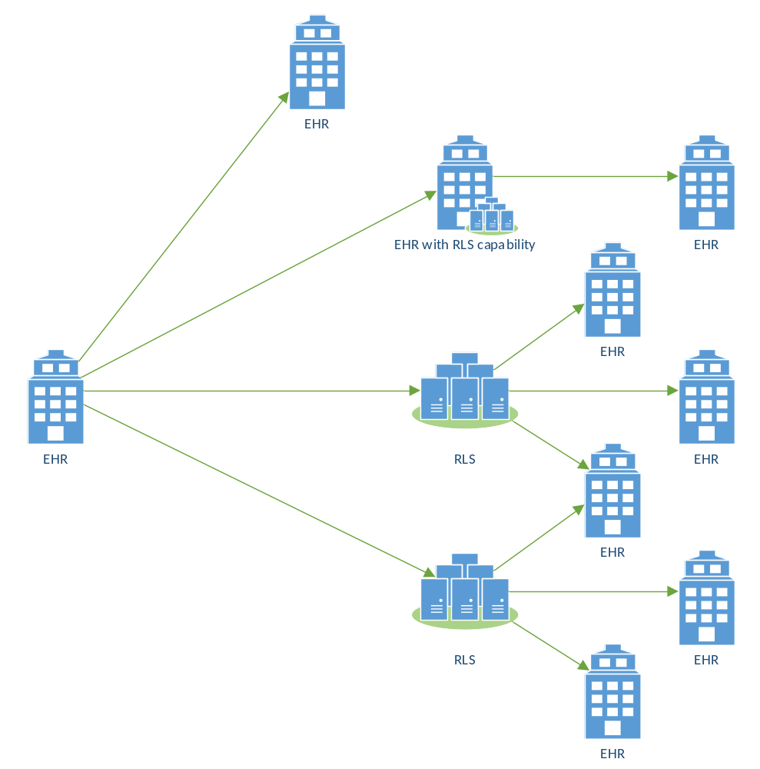
SAMPLE
Figure 1 - RLS Architecture
Any number of RLS and EHR systems can be members of the network. There are different interactions between the RLS and the EHR, depending on the EHR's capabilities:

Location EHR with XCA Support
[Insert Description]

Location EHR with Direct Messaging Support, Using the RLS as a Gateway
[Insert Description]

RLS Serving As a Location EHR
[Insert Description]

Technical Requirements
[Insert Description]

Detailed Architecture
[Insert Description]

Implementation Guides

Simple Query
Known interop issues
ID | Transaction | Initiating System | Responding System | Issue | Status | Resolution
1 | ITI-38 Cross Gateway Query | eHEX 2010 IG | Any XCA RG not supporting on-demand | IG may use eHEX-specific query for status of DeferredCreation in order to get dynamic docs. Typical: Approved OR DeferredCreation (i.e. return both) | Assumed ok | RG should ignore unknown status values. (Approved OR DeferredCreation) would become just Approved.
2 | ITI-38 Cross Gateway Query | eHEX 2010 IG | Any XCA RG supporting on-demand | IG may use eHEX-specific query for status of DeferredCreation in order to get dynamic docs. Typical: Approved OR DeferredCreation (i.e. return both) | Needs adapting | One side needs to adapt to other side, or else only stable docs will be obtained.
3 | ITI-38 Cross Gateway Query | Any XCA IG not supporting on-demand | Any XCA RG supporting on-demand | IG will query for stable docs only. RG may not have stable versions of some/all docs, limiting access to clinical info. | Needs workaround | Option: RG could return on-demand
3 | ITI-38 Cross Gateway Query | Any XCA IG not supporting on-demand | eHEX 2010 RG with dynamic documents | IG will query for stable docs only. RG may not have stable versions of some/all docs, limiting access to clinical info. | Needs workaround
4 | ITI-38 Cross Gateway Query | Any XCA IG supporting on-demand | eHEX 2010 RG with dynamic documents

Record Locator Service

