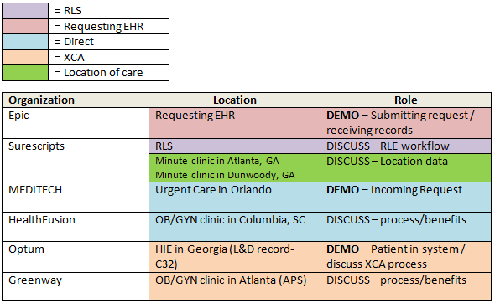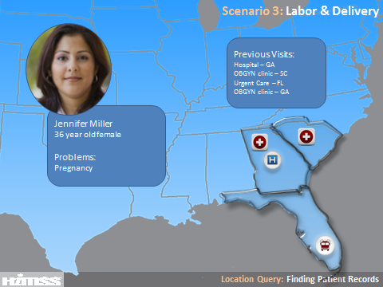
Jennifer Miller is a 36 year-old female who lives in Atlanta, Georgia with her husband and 5 year old son. She and her family moved from Macon, Georgia to Atlanta 2 years ago. She is currently 37 weeks pregnant. Her pregnancy is classified as a high-risk pregnancy as she has had a prior miscarriage and is of advanced maternal age. When she was vacationing in Orlando, Florida at 22 weeks gestation, she was seen in the Emergency Room for vaginal bleeding and suspected miscarriage. Dr. Emerson, her OB/GYN physician in Atlanta, has been monitoring her pregnancy. She presents to the hospital today in the late stages of labor. Dr. Emerson, who is a visiting physician at this hospital, is on vacation. Since the hospital uses a different electronic health record, the on-call OB/GYN (Epic) utilizes the Record Locator Service (Surescripts) to quickly access information about Jennifer’s prenatal care and previous medical history found in her other medical records including her L&D record from her previous delivery in Macon (Optum), an OB/GYN clinic in Columbia SC (HealthFusion), an urgent care in Orlando (MEDITECH), two minute clinics in Georgia (Surescripts) and her prenatal record from the OB/GYN clinic in Atlanta (Greenway).
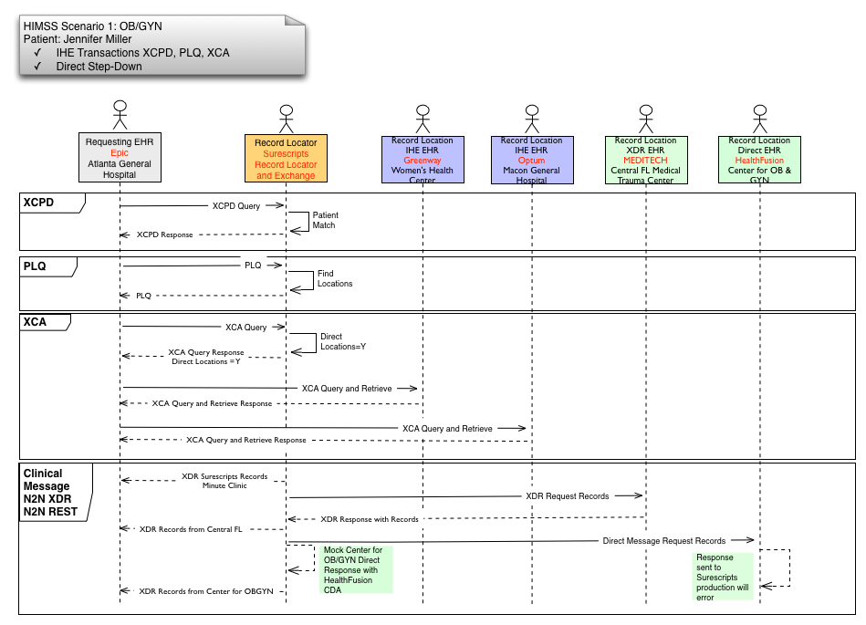

Script for Scenario 3 – L & D
Players
RLS- Surescripts
Requesting EHR- Epic
Location EHRs- Optum, HealthFusion, MEDITECH, Greenway
Demo Workflow
- Patient presents
  - Epic rep tells patient story and overview of scenario (show intro slide)
    - In this scenario we’re following Jennifer Miller, a 36 year old who’s 37 weeks pregnant. She’s had previous encounters for this pregnancy at other organizations.
    - Her OB/GYN who’s been following the pregnancy is on vacation. He uses another EMR in his clinic so the information from those encounters isn’t immediately available.
    - She presents today to the ED in labor. As part of the process in the ED I want to see if the patient has outside records.
- Epic requests locations from Surescripts (demo)
    - To get a list of organizations where the patient has been seen for care, I’ll request the locations through Surescripts Record Locator and Exchange.
    - I can access that through the Phonebook in Care Everywhere
- Epic collect authorization from the patient. (demo)
    - I can see that I need to gather authorization from the patient to retrieve this info through the RLS. I’ll gather that now at the point of care.
- Surescripts matches patient and provides locations (background)
- Epic chooses which locations to request records and sends request for records(demo)
    - We can see that Jennifer has been to a number of healthcare organizations.
    - Now that I have the list of locations where the patient has been, I’ll send a query to retrieve the patient’s record from those organizations.
- Choose all locations
- MEDITECH (Direct) shows incoming request and sending of record (demo)
    - Shows the request in the Direct Message Center routine.
    - Explains how this routine is ideally suited for Medical Records and that relationships with querying entities as part of this community HIE are already established.
    - Replies to Message with a CCDA file for Jenny Miller
  - Routed through Surescripts (background)
  - Surescripts- Discuss Direct step-down capabilities (slide shown on screen)
    - Direct step-down bridges the gap between standards and enables non-IHE enabled vendors to participate, expanding the reach and breadth of patient information we can find
- XCA transactions take place between Epic and IHE vendors (background)
  - Optum demos their patient in their system and discusses XCA process (demo)
    - Show patient chart in demo system
    - Point out certain pieces of information that will be provided to eCW
- Epic receives all 6 documents
- Macon General Hospital – Optum (HIE)
- Center for Obstetrics and Gynecology- HealthFusion
- Minute Clinic- Surescripts
- Minute Clinic- Surescripts
- Central Florida Medical Center- MEDITECH
- Women’s Health Center- Greenway
- Epic shows receipt of all documents and each vendor explains process/benefits (demo)
    - I can see that all of the organizations had a matching patient in their databases, and they’ve sent me summaries of care based on their information.
    - I can dig into the different summaries to see key data like allergies and medications.
  - Greenway
  - HealthFusion
  - Surescripts
    - Patient matching and identifying visit locations
    - Patient consent
    - Discover patient visit locations through transaction data
    - Facilitate exchange of patient information

Conclusion (Epic):
We can see that there’s huge potential in using a record locator service, especially for patients with chronic conditions and a rich medical history. This service puts less of a burden on the patient to detail past encounters and gives the clinicians a more complete record to inform their care.

