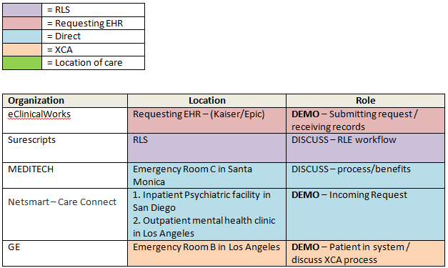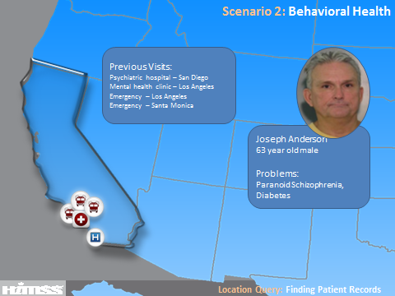
Joseph Anderson is a 63 year-old male who lives in a homeless shelter and on the streets in Los Angeles, California. He has had various encounters with the law and is a frequent flyer of Emergency Departments in the area. Today, Joseph presents to a Trauma Center in Los Angeles after the police found him behaving irrationally and destructively and with what appears to be self-inflicted injuries to his arms and face. Joseph is unable to provide coherent history of present illness or any past medical history and not accompanied by any family or friends. In order to make informed care decisions and provide life-saving care to Joseph, the ED physician, Dr. Jacobs (eCW), needs access to his medical records. Utilizing the Record Locator Service (Surescripts), relevant care information is pushed to Dr. Gordon from Joseph’s records discovered at an inpatient psychiatric facility (Netsmart), an outpatient mental health clinic (Netsmart) and various emergency departments (GE & MEDITECH) throughout Los Angeles.
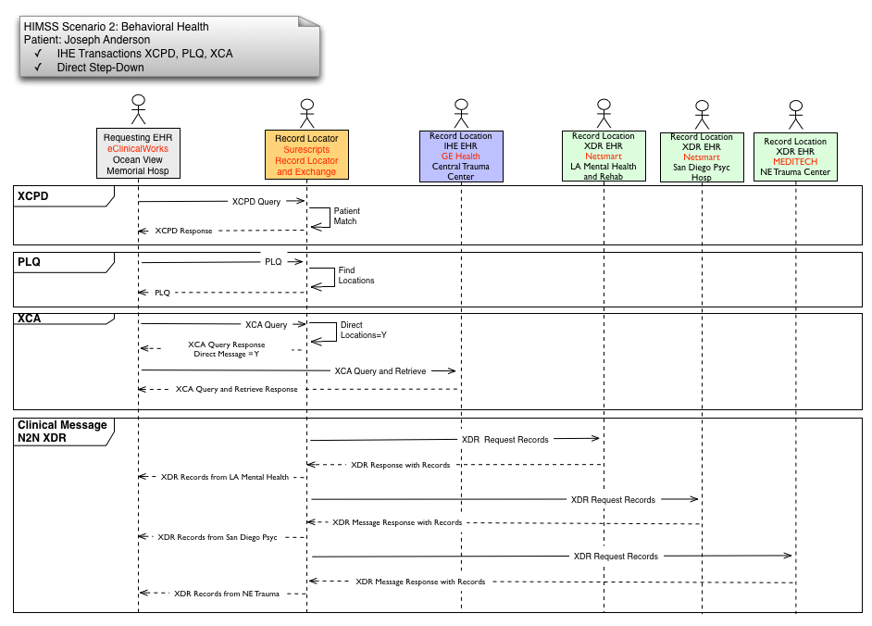

Players
RLS- Surescripts
Requesting EHR- eClinicalWorks
Location EHRs- GE, MEDITECH, Netsmart
Demo Workflow
- Patient presents
  - eClinicalWorks rep tells patient story and overview of scenario(show intro slide)
    - We’re following the patient, Joseph Anderson, who just presented to the ED in Los Angeles.
    - As part of my process I always ask patients where else they may have a medical record. In this case, Joseph appears to be confused and not very responsive so he is unable to provide me with any medical history.
- eClinicalWorks requests locations from Surescripts (demo)
  - To get the complete list, I’ll use the Surescripts Record Locator and Exchange
- Surescripts matches patient and provides locations (background)
- eClinicalWorks chooses which locations to request records and sends request for records(demo)
  - Choose all locations
    - We can see that Joseph has been to a number of healthcare organizations.
    - Now that I have the list of locations where the patient has been, I’ll send a query to retrieve the patient’s record from those organizations.
- NetSmart (Direct) shows incoming request and sending of record (demo)
    - Actual transaction occurs in the background
    - Netsmart will demo the patient’s chart
    - Discuss Netsmart solution notified of query request via CareConnect
- Routed through Surescripts (background)
- Surescripts - Discuss Direct step-down capabilities (slide shown on screen)
    - Direct step-down bridges the gap between standards and enables non-IHE enabled vendors to participate, expanding the reach and breadth of patient information we can find
- XCA transactions take place between eClinicalWorks and IHE vendors (background)
  - GE demos their patient in their system and discusses XCA process (demo)
    - Show patient chart in demo system
    - Point out certain pieces of information that will be provided to eCW
- eClinicalWorks receives all 4 documents
  - San Diego Psychiatric Hospital- NetSmart
  - Central Trauma Center- GE
  - Northeast Medical Center- MEDITECH
  - Los Angeles Mental Health & Rehabilitation Services- NetSmart
- eClinicalWorks shows receipt of all documents and each vendor explains process/benefits (demo)
  - eCW -- develop a brief “script” here for describing the data we’ve received, highlight the different types of players esp. mental/behavioral health from Netsmart
  - MEDITECH
    - Explains how this routine is ideally suited for Medical Records
    - Relationships with querying entities as part of this community HIE are already established.
    - Replies to Message with a CCDA file for Joseph Anderson
  - Surescripts
    - Patient matching and identifying visit locations
    - Patient consent
    - Discover patient visit locations through transaction data
    - Facilitate exchange of patient information

Conclusion (eCW):
We can see that there’s huge potential in using a record locator service, especially for patients who are unable to provide an account of their medical history. This service puts less of a burden on the patient to detail past encounters and gives the clinicians a more complete record to inform their care.

