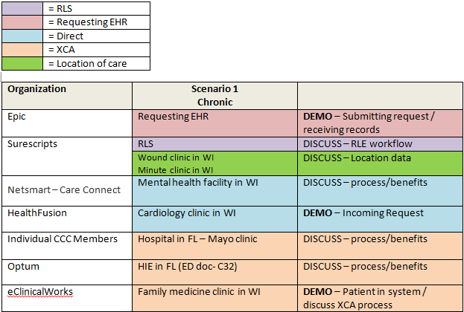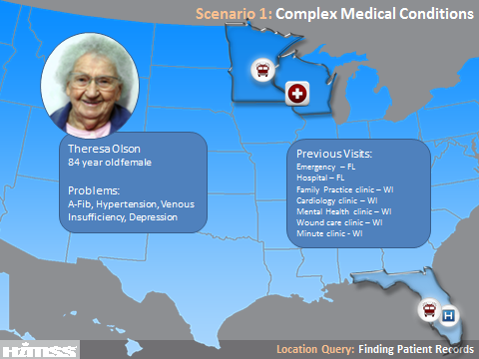
Theresa Olson is an 84 year old female who lives alone in her home in La Crosse, WI. Her husband recently passed away and her daughter, Julie, is now looking in on her mother. Theresa and her husband used to spend winters in Ocala, Florida. Two years ago, Theresa was taken to a Hospital in Florida for a severe UTI and leg ulceration. She was admitted for IV antibiotic treatment where she had a severe allergic reaction to the antibiotics. She was also diagnosed with atrial fibrillation and hypertension. After discharge, she returned to the hospital and was admitted to the ICU with pneumonia. One month ago she was seen by her family doctor in La Crosse, WI for a leg ulceration resulting from venous insufficiency. She also regularly sees a cardiologist and is treated at a mental health clinic for Depression. Theresa is currently visiting her daughter in Minneapolis, MN. Julie brings her mother to the emergency room (Epic) with leg infection, irregular heartbeat and suspicion of pneumonia. Julie is able to inform the emergency physician, Dr. Tina Jones, of some of Theresa’s past history, but cannot remember everything. Utilizing the Record Locator Service (Surescripts), relevant care information is pushed to Dr. Jones from Theresa’s records discovered at various health care entities: an emergency visit in Florida (Optum), a hospital stay in Florida (CCC-Mayo), her family doctor in La Crosse (eCW), her Cardiologist in La Crosse (HealthFusion), a wound care clinic in La Crosse (Surescripts), a minute clinic in Onalaska WI (Surescripts) and an outpatient mental health clinic in La Crosse (Netsmart).
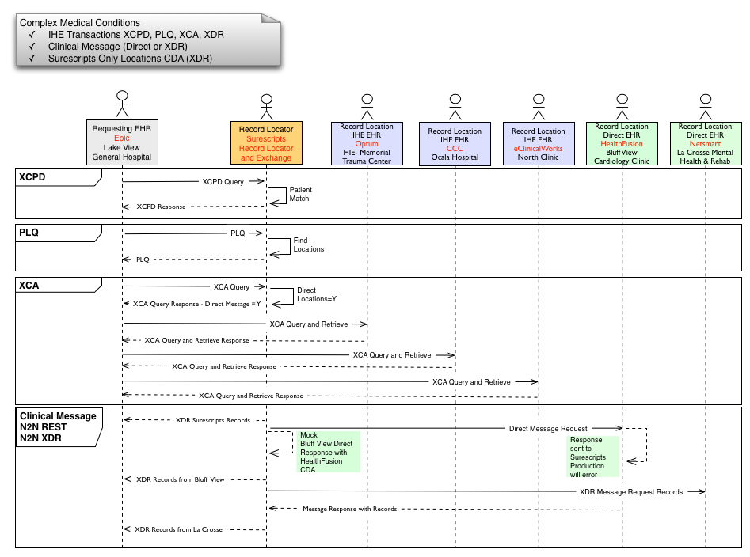

Players
RLS- Surescripts
Requesting EHR- Epic
Location EHRs- CCC, Netsmart, Optum, HealthFusion, eClinicalWorks
Overview (Epic):
Organizations have been taking advantage of interoperability standards to exchange patient records for many years now. This has given providers a more complete picture of the patient and improved continuity of care.
Still, one of the challenges has been determining which organizations to query. It currently relies primarily on the patient to remember where he’s been. The demonstration today will cover enhanced workflows that leverage a record locator service, using widely deployed IHE profiles, to get a more complete list of organizations to query.
- Patient presents
  - Epic rep tells patient story and overview of scenario (show intro slide)
    - We’re following the patient, Theresa Olson, who just presented to the ED in Minneapolis accompanied by her daughter.
    - I’m starting off as a triage nurse in the ED. I’m ready to see Theresa. As part of my process I always ask patients where else they may have a medical record. In this case, Theresa’s and her daughter recall some places, but they acknowledge they can’t remember all of it.
- Epic requests locations from Surescripts (demo)
    - To get the complete list, I’ll use the Surescripts Record Locator and Exchange from the Phone Book in Care Everywhere
- Epic collect authorization from the patient. (demo)
    - I can see that I need to gather authorization from the patient to retrieve this info through the RLS. I’ll gather that now at the point of care.
- Surescripts matches patient and provides locations (happens in background)
- Epic chooses which locations to request records and sends request for records(demo)
  - Choose all locations
    - We can see that Theresa has been to a number of healthcare organizations.
    - Now that I have the list of locations where the patient has been, I’ll send a query to retrieve the patient’s record from those organizations.
- HealthFusion (Direct) shows incoming request and sending of record (demo)
    - Show patient chart in demo system
    - Show incoming request and sending of CDA (Flip away before error message)
  - Routed through Surescripts (happens in background)
  - Surescripts - Discuss Direct step-down capabilities (slide shown on screen)
    - Direct step-down bridges the gap between standards and enables non-IHE enabled vendors to participate, expanding the reach and breadth of patient information we can find
- XCA transactions take place between Epic and IHE vendors (happens in background)
  - eClinicalWorks demos their patient in their system and discusses XCA process (demo)
    - Show patient chart in demo system
    - Point out certain pieces of information that will be provided to eCW
- Epic receives all 7 documents
  - Ocala Emergency Care- Optum
  - Ocala Hospital- CCC
  - La Crosse Wound Care Clinic - CDA from SS
  - La Crosse Minute Clinic – CDA from SS
  - North Clinic- eClinicalWorks
  - Bluff View Cardiology Clinic- HealthFusion
  - La Crosse Mental Health & Rehabilitation Services- NetSmart
- Epic shows receipt of all documents and each vendor explains process/benefits (demo)
    - Epic -- develop a brief “script” here for describing the data we’ve received, highlight the different types of players esp. mental/behavioral health from Netsmart, HIE aggregation from Optum.
- CCC- Mayo
- NetSmart
- Optum
    - Coordinating patient care is difficult absent the ability to quickly exchange information and communicate in a secure environment.
    - We built Optum HIE to simplify and accelerate information exchange supporting a wide range of care coordination activities, from referrals to care management, following IHE profiles that qualify our technology for this interoperability demonstration.
    - Optum HIE solutions implement the IHE Cross-Community Access (XCA) standard which allows the sharing of patient demographic and clinical information across communities where the patient lives and works. This information is shared quickly, accurately and in a secure manner and irrespective of the end-user tools that are in place.
    - The key benefits include increased efficiency, enhanced care coordination and better patient safety.
- Surescripts
    - Patient matching and identifying visit locations
    - Patient consent
    - Discover patient visit locations through transaction data
    - Facilitate exchange of patient information
Conclusion (Epic):
We can see that there’s huge potential in using a record locator service, especially for patients with chronic conditions and a rich medical history. This service puts less of a burden on the patient to detail past encounters and gives the clinicians a more complete record to inform their care.

